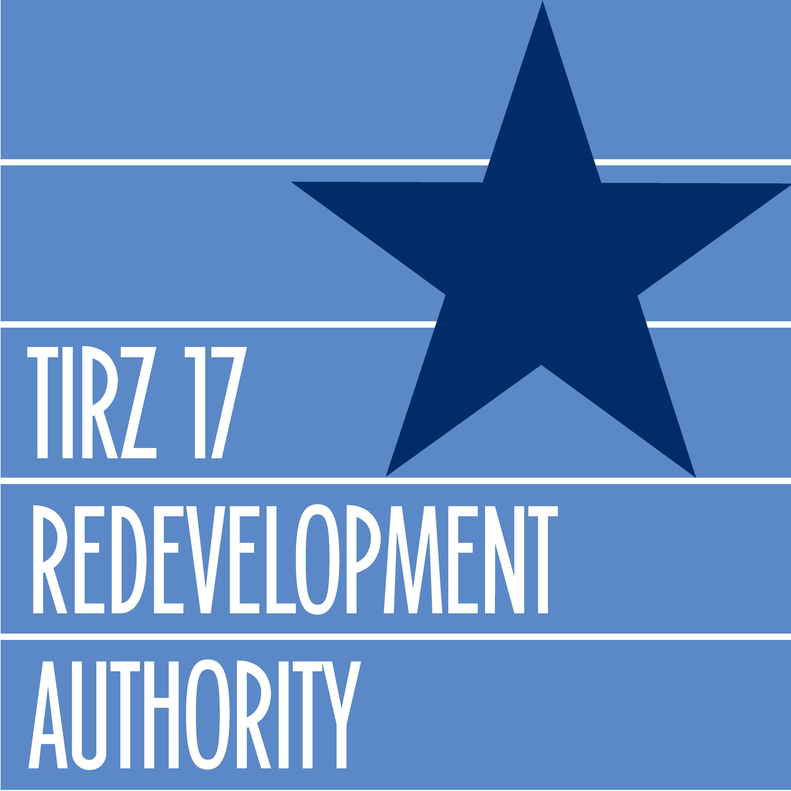

The Gessner Road Widening Project will transform this great urban boulevard into a pedestrian-friendly thoroughfare and create a signature entryway to welcome residents and visitors to the Memorial City area. These improvements include more lanes, wider sidewalks, improved drainage and picturesque landscape.
The Gessner Widening Project is a joint effort between the TIRZ-17 Redevelopment Authority and the Texas Department of Transportation to rebuild a better street. Construction will begin June, 2008. The project is forecasted to last 18-months.
Widening the section of Gessner Road, which runs parallel to the Memorial City Mall and the Memorial Hermann Memorial City Medical Center will improve traffic flow south of I-10 with the addition of a fourth lane in each direction. Additional lanes for turning movements will be added in both the north and south bound direction. These dedicated turn lanes will minimize traffic flow disturbance caused by the heavy access demand for adjacent businesses. All of the improvements are imperative because Gessner Road is a busy commercial corridor home to retail, medical facilities and restaurants.
Improved drainage and reduced street flooding are two more benefits of reconstructing Gessner Road. Two five-foot by eight-foot box culverts will replace the single smaller pipe that currently conveys the rainfall runoff to drainage channel W151. Increased watershed storage from the oversized culverts will benefit W151 by providing detention during big rain events; the two proposed box culverts connect into an existing 60-inch pipe that conveys the water to ditch W151. The existing 60-inch pipe acts as a restrictor limiting the flows from the new box culverts to W151. A larger storm sewer is also advantageous to W153, also known as Buffalo Bayou, by reducing overland sheet flow.
Another welcome addition to the Gessner Road Widening Project is wider sidewalks. Currently, Gessner Road lacks a sufficient sidewalk system for friendly pedestrian traffic. That’s because the sidewalk is either too narrow on the west side or is non-existent on the east side. A new network of eight-foot wide sidewalks will connect residential neighborhoods to shopping, transit and work and convert the Memorial City area into a walkable community.
Other scenic street designs to better accommodate pedestrians, shoppers and tourists alike include theater-style street lamps, improved signage, bus stop enhancements and landscape planting. More than 100 large shade trees, along with hundreds of shrubs and flowers will transform this active city street into a scenic streetscape people will want to visit.
In the end, the Gessner Widening Project will reveal a scenic and bustling thoroughfare to serve as the gateway to connecting people with businesses within the Memorial City area.

