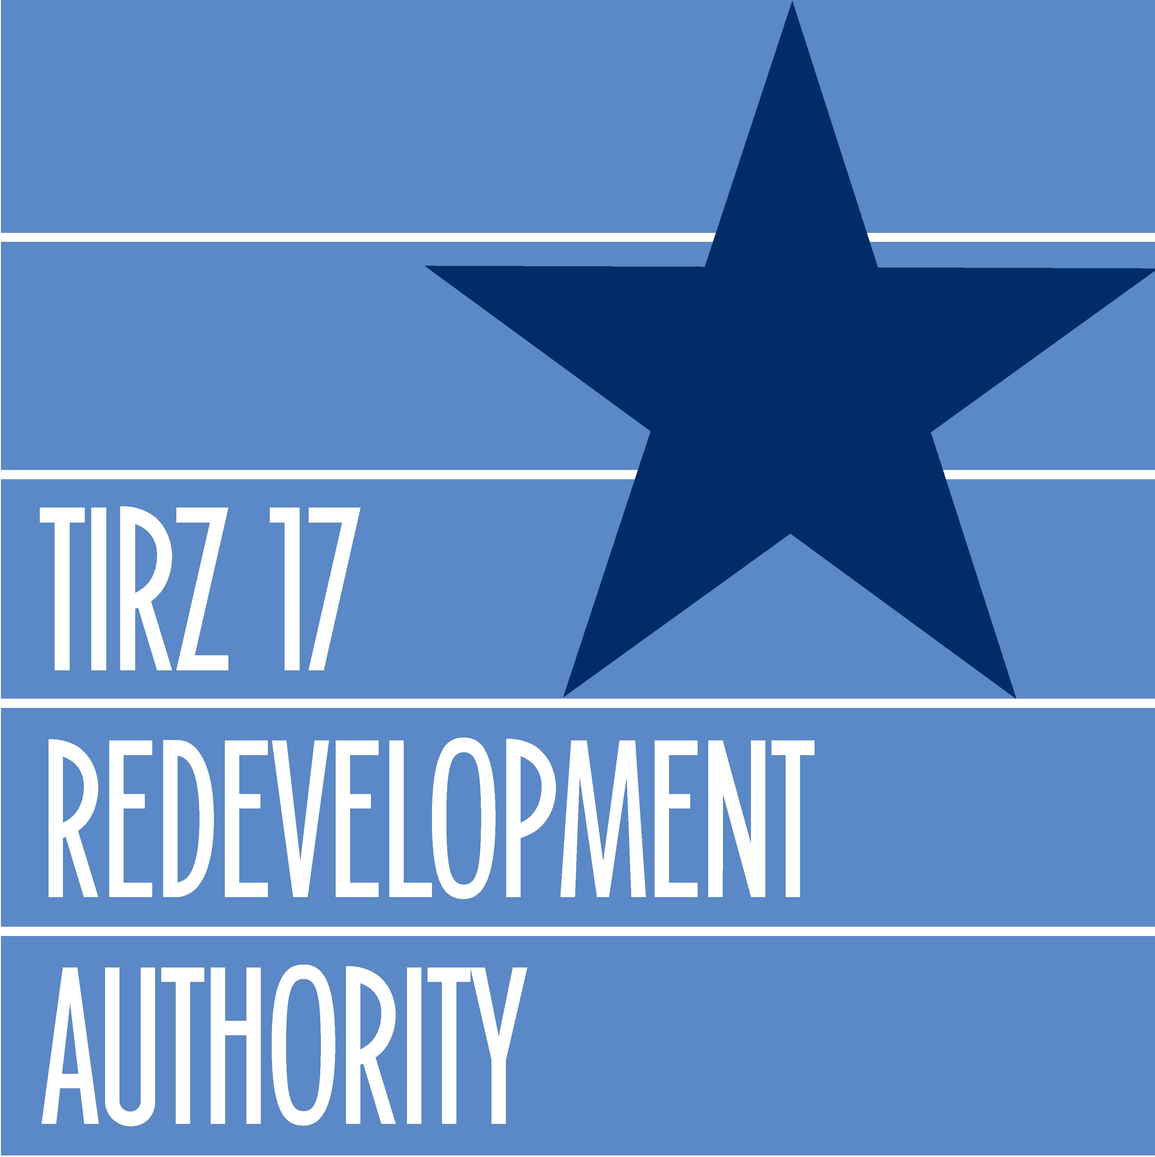

GESSNER ROAD WIDENING IMPROVEMENT PROJECT
FAST FACTS

What: Widen the road from a six-lane divided boulevard to an eight-lane divided boulevard street section, increase turn lanes, update traffic signal system, improve drainage by installing two 8 ft. X 5 ft. box culverts, and enhance the streetscape.

Where: Gessner Road between IH-10 and Barryknoll Lane

When: Utility adjustments and coordination of work is underway. Groundbreaking for the roadway reconstruction contract is scheduled for June. Construction completion along with the streetscape installation is forecasted for the end of 2009.

Why: Adding additional travel lanes, improve turning movements and traffic flow, improve surface drainage with added detention, wider sidewalks, and enhanced streetscape is necessary because Gessner Road is a busy commercial corridor and home to retail, medical facilities and restaurants.

Who: The project is a jointly funded effort between the TIRZ-17 Redevelopment Authority and the Texas Department of Transportation (TxDOT). The TIRZ was responsible for design engineering and TxDOT will oversee construction management.

How much: The cost for improving this segment of Gessner Road is approximately ten million dollars.

